How to submit your work to GitHub Classroom

This document will guide you through the submission process for the Spring 2026 Hack-AI-Thon hosted by WAIAI and sponsored by Expedia™. Please follow the steps carefully. This is also not the only place you will be submitting materials. Please submit the rest of your work through Survey Monkey Apply. Important: the repositories will be private during the Hack-AI-thon, but after the submission deadline they will be made PUBLIC. This is so you can share your hard work with others after the Hack-AI-thon is over!

- First, follow this link: https://classroom.github.com/a/62ykpBfA. You will need to login to your GitHub account. There is no need to create a one specifically for this Hack-AI-thon. Feel free to use a preexisting one or if you do not have one, please create one.
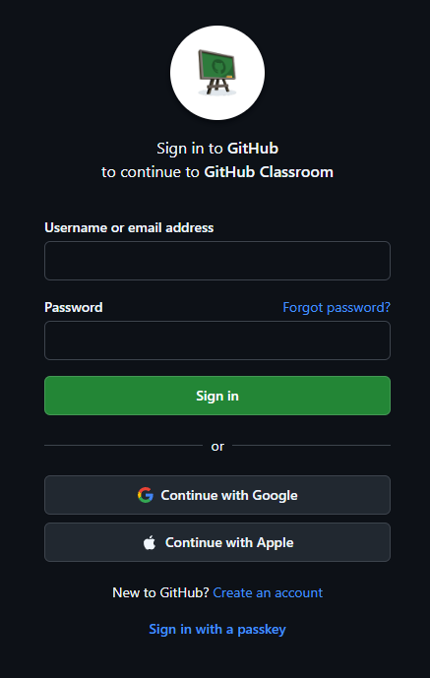

The link will take you here, follow step 1.

Next page →
- Once you log in you will be prompted to create a new team or join an existing team.
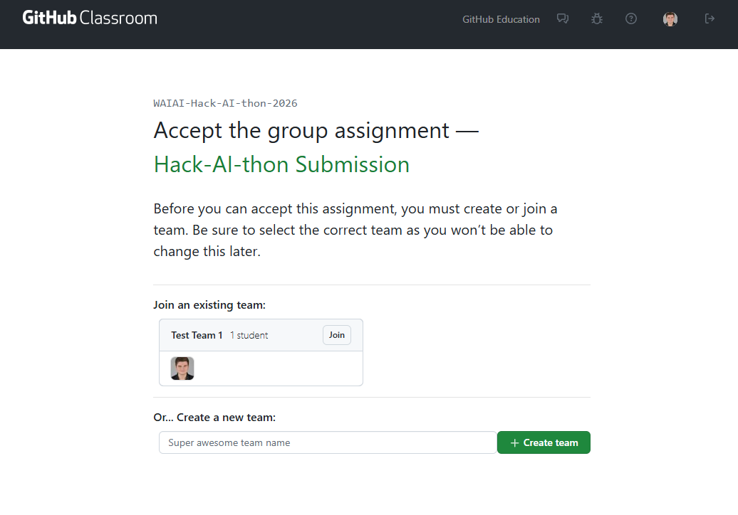

- After creating or joining your team you will then have to accept the assignment. Once this is done it will create a GitHub Repository for you and your team to work in.
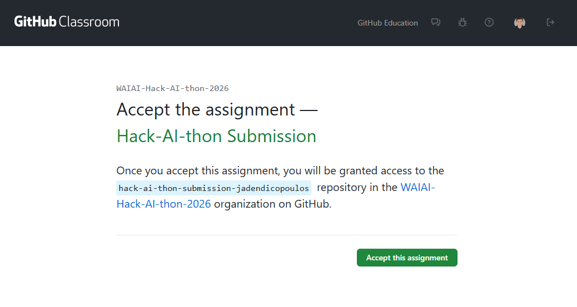

Next page →
- Once you click accept, you will be redirected to the page below where you will be able to go to your team’s repository.
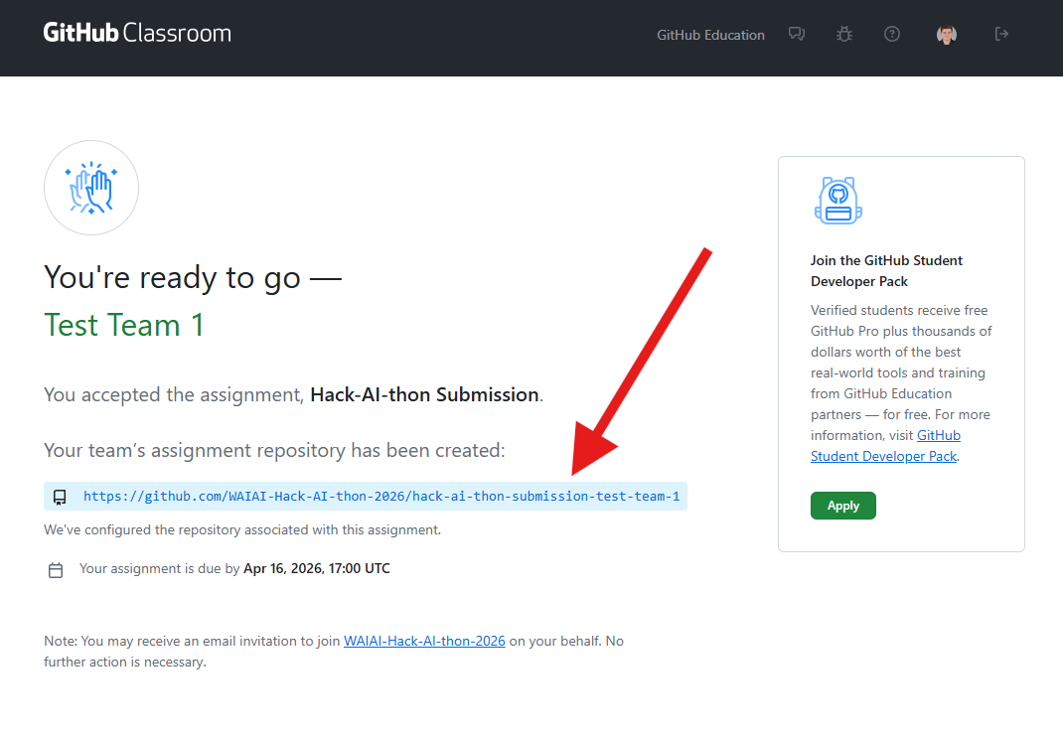

Be sure to save the link to your Repository!

- You are all set! Your repository will look like the picture below. This is where you will host all of your code.
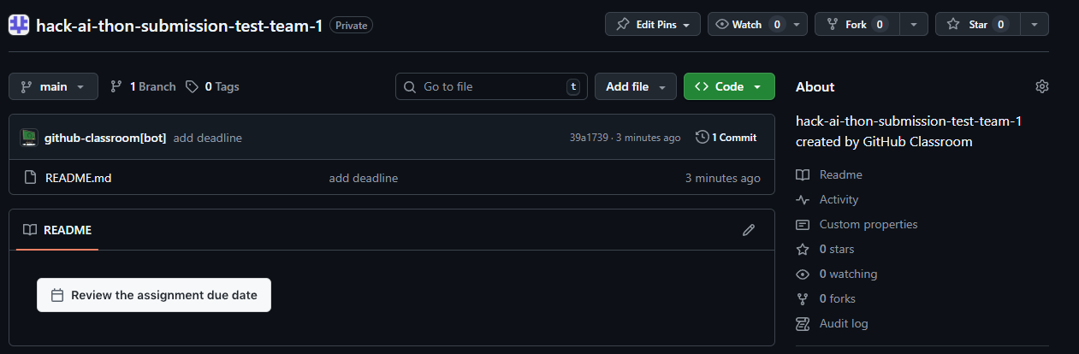

Next page →

Important things to note:
- Check your email if you lose the link to your repository. A link will be sent to you there.
- If you have any questions, please feel free to reach out to the WAIAI team.
- Once again, the repositories will be private during the Hack-AI-thon, but after the submission deadline they will be made public.
- If you are using an API key, make sure it is hidden properly. GitHub repos that are published may be taken down if GitHub detects an API key. This is to prevent it from being leaked online.

